

**department of Computer Engineering & Applications**

**INSTITUTE OF ENGINEERING & TECHNOLOGY**

**B.Tech. III Year CSE**

**Project Report**

**On**

**‘Notes Gallery’**

**Under the supervision of** **Submitted by**

**Mr. Amir Khan 1**. Rozi (H-50/181500595)

**2.** Ayushi Srivastava (H-11/181500185)

3. Ayushi Rathi (D-8/181500184)

**Group No:**

**Odd Semester, 2020-21**

***DECLARATION***

*We hereby declare that the work which is being presented in the Mini Project* ***“Notes Gallery”****, in partial fulfillment of the requirements for Mini-Project LAB, is an authentic record of our own work carried under the supervision of* ***Amir Khan Technical Trainer (CEA) GLA University, Mathura.***

**Date:**

**Place:**

**Name of Students with signature:**

1. Sign ______________________

Name of Candidate: **Rozi**

University Roll No.:**181500595**

2. Sign ______________________

Name of Candidate: **Ayushi Srivastava**

University Roll No**.:181500185**

3. Sign ______________________

Name of Candidate: **Ayushi Rathi**

University Roll No**.:181500184**

***CERTIFICATE***

*This is to certify that the project entitled* ***“Notes Gallery”*** *carried out in* ***Mini Project – I*** *Lab is a bonafide work done by* ***Rozi (181500595), Ayushi Srivastava (181500185) and* Ayushi Rathi (181500184)** *and is submitted in partial fulfillment of the requirements for the award of the degree* ***Bachelor of Technology (Computer Science Engineering).***

**Signature of Supervisor:**

**Name of Supervisor:**

**Date:**

***ACKNOWLEDGEMENT***

It gives us a great sense of pleasure to present the report of the B. Tech Mini Project undertaken during B. Tech Third Year. This project in itself is an acknowledgement to the inspiration, drive and technical assistance contributed to it by many individuals. This project would never have seen the light of the day without the help and guidance that we have received.

Our heartiest thanks **to Dr. (Prof). Anand Singh Jalal**, Head of Dept., Department of CEA for providing us with an encouraging platform to develop this project, which thus helped us in shaping our abilities towards a constructive goal.

We owe special debt of gratitude to **Amir Khan**, Technical Trainer Department of CEA, for his constant support and guidance throughout the course of our work. His sincerity, thoroughness and perseverance have been a constant source of inspiration for us. He has showered us with all his extensively experienced ideas and insightful comments at virtually all stages of the project & has also taught us about the latest industry-oriented technologies.

We also do not like to miss the opportunity to acknowledge the contribution of all faculty members Of the department for their kind guidance and cooperation during the development of our project. Last but not the least, we acknowledge our friends for their contribution in the completion of the project.

**Rozi**

**Ayushi Srivastava**

**Ayushi Rathi**

***ABSTRACT***

As the world is being developed with the new technologies, discovering and manipulating new ideas and concepts of taking everything online are rapidly changing. It is difficult for teachers to circulate their notes to each and every student whom is he/she teaching. College Notes Gallery provide an easy approach for both students and teachers to circulate the notes whether of any kind like lecture notes, assignment questions, question papers and all the important documents.

The teachers and students can upload the documents from anywhere and students can download it. Overall, it is managed by the admin.

***INDEX***

1. Introduction

* 1. Motivation and Overview
  2. Existing System and its’s Limitations
  3. Need of Proposed System
  4. Intended Audience
  5. Objective

2. Proposed System

2.1 Problem Statement

2.2 Objectives of Proposed System

2.3 Module Specification

2.4 Operating Environment

* 1. Application

3. Diagrams

* 1. Use case
  2. Sequential

4. Screenshots

4.1 Home Page

4.2 Upload Page

4.3 About Page

* 1. Code

5. Conclusion

6. Bibliography

**Chapter 1**

**Introduction**

**1.1 Motivation and Overview**

In this era of new technologies and rapid development it is difficult for teachers to circulate their notes to each and every student whom he/she is teaching. Also we have seen that during examinations there is a lot of search for proper notes which thereby creates a mess among students. Also the notes hence shared then on other social platforms are not in synchronised order. The Notes Gallery will provide an easy approach to circulate the notes and will therefore solve the problem of many students.

**1.2 Existing System and its’s Limitations**

Mostly the notes are circulated on WhatsApp or any kind so it gets very difficult to manage the important notes at the time of need.

**1.3 Need of Proposed System**

My system will provide an easy approach to share the documents for studying purpose. Multiple users can work simultaneously on the system. It will be easy for the teachers to circulate the notes to each and every student.

**1.4 Intended Audience**

The system will be used by students and teachers in colleges and even it can be used by schools.

**1.5 Objective**

The Objective of Class Notes Gallery is to provide better facility to the students and teachers to bring out the easy circulation of documents within healthy environment. It will reduce the manual paperwork, reduced the sharing and distribution time.

**Chapter 2**

**Proposed system**

**2.1 Problem Statement**

There are many students who face problem in studying at the exam time because either they don’t have the notes provided by teachers or they must have not been in the college. This System will provide a platform to easily access the notes.

**2.2 Objectives of Proposed System**

The Objective of Class Notes Gallery is to provide better facility to the students and teachers to bring out the easy circulation of documents within healthy environment. It will reduce the manual paperwork, reduced the sharing and distribution time.

**2.3 Module Specification**

**Student:**

Students register on the website and login to access the notes uploaded by teachers and view them or download it.

**Teacher:**

The teacher has to first register on the website and then login to upload the note. Teacher can even delete the notes by logging in.

**Notes:**

Notes can be uploaded and deleted by teacher and student. It can be downloaded by every student and teacher.

**Admin:**

The notes are managed by admin. He has rights to approve or disapprove the notes uploaded by particular user.

**2.4 Operating Environment**

**Hardware Requirements**

* CORE 2 Duo PROCESSOR
* RAM 1 GB
* HARD DISK 10 GB
* CACHE MEMORY 512 KB

**Software Requirements**

* WINDOWS OPERATING SYSTEM
* PHP
* MySQLi
* HTML, CSS, JAVASCRIPT, BOOTSTRAP
* XAMP
* APACHE SERVER
* SUBLIME TEXT EDITOR

**2.5 Application**

* Medicine: Bloodless surgery. laser healing, surgical treatment, kidney stone treatment, eye treatment, dentistry.
* Industry: Cutting, welding, material heat treatment, marking parts, non-contact measurement of parts.
* Military: Marking targets, guiding munitions, missile defense, electro-optical countermeasures (EOCM), alterative to radar, blinding troops.
* Law enforcement: used for latent fingerprint direction in the forensic identification field.
* Research: Spectroscopy, laser ablation, laser annealing, laser scattering, laser interferometry, lidar, laser capture microdissection, fluorescence microscopy.

**Chapter 3**

**Diagrams**

**3.1 Use-Case Diagram**

Use case diagrams  consist of actors, use cases and their relationships. The diagram is used to model the system/subsystem of an application. A single use case diagram captures a  particular functionality of a system.

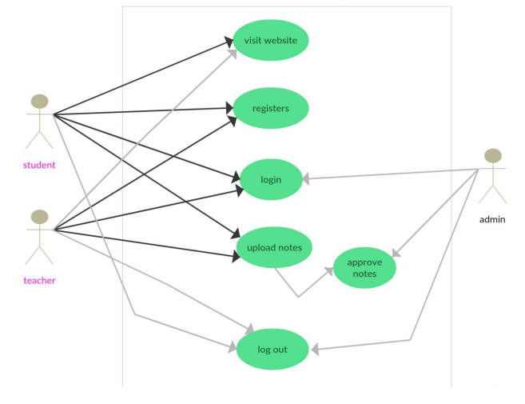

**3.2 Sequence Diagram**

Sequence diagram simply depicts interaction between objects in a sequential order i.e. the order in which these interactions take place. We can also use the terms event diagrams or event scenarios to refer to a sequence diagram. Sequence diagrams describe how and in what order the objects in a  system function.

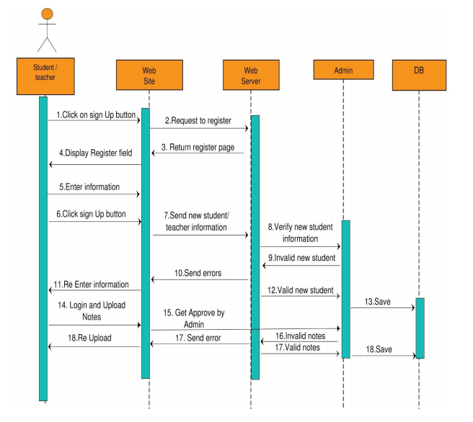

**Chapter 4**

**Screenshots**

**4.1 Home page**

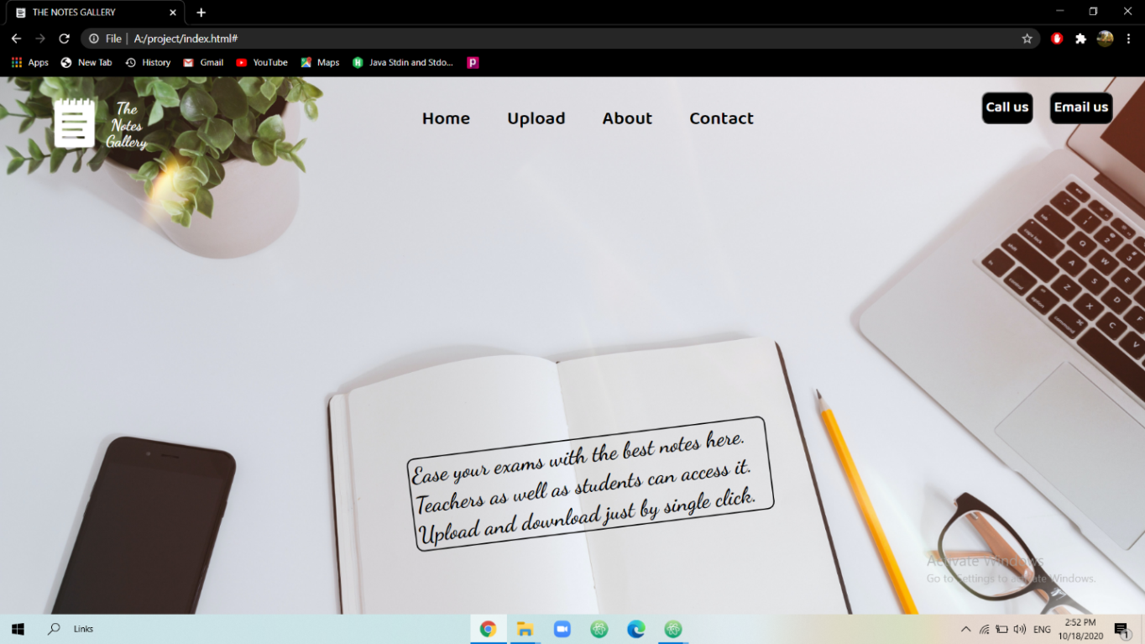

**4.2 Upload Page:**

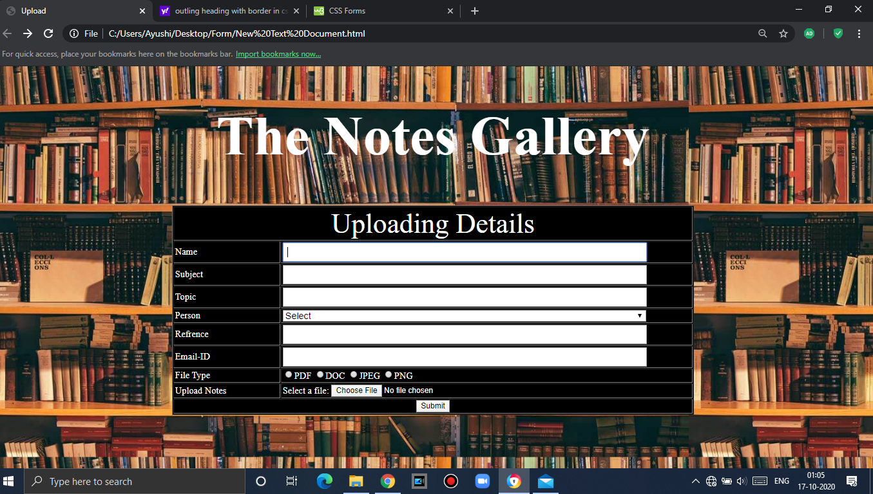

**4.3 About page**

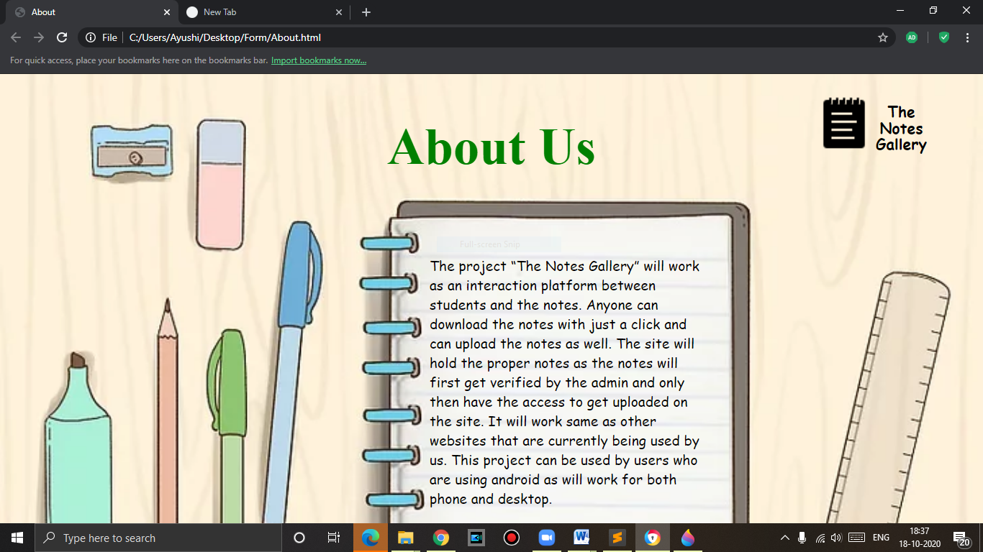

**4.4 Code:**

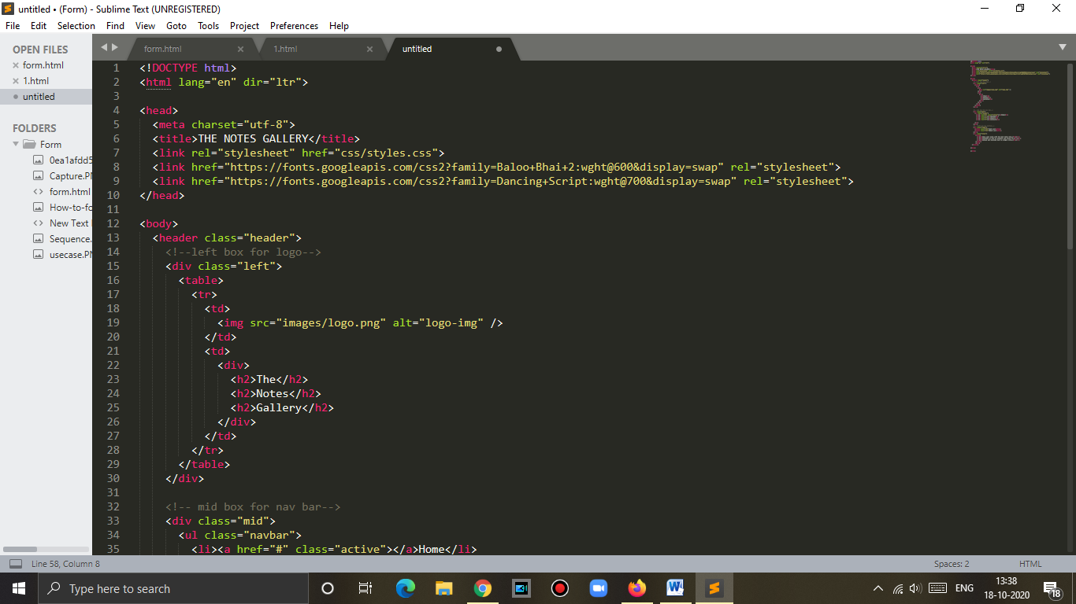

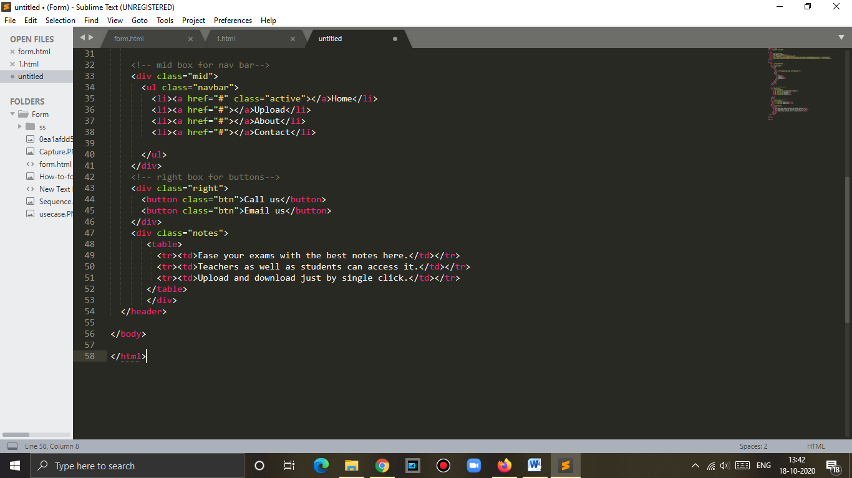

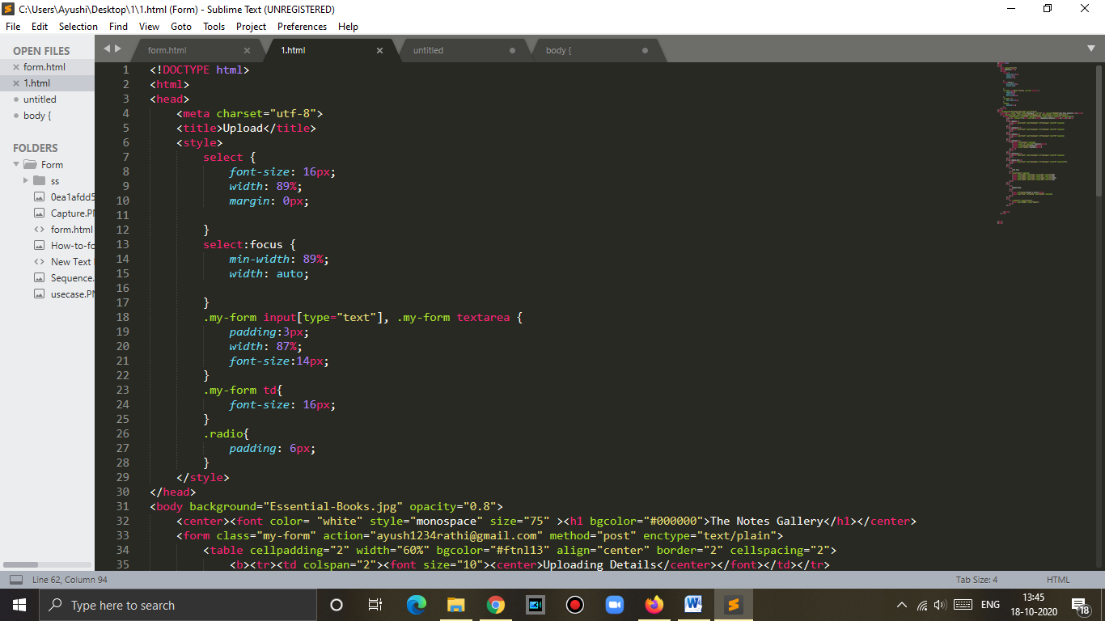

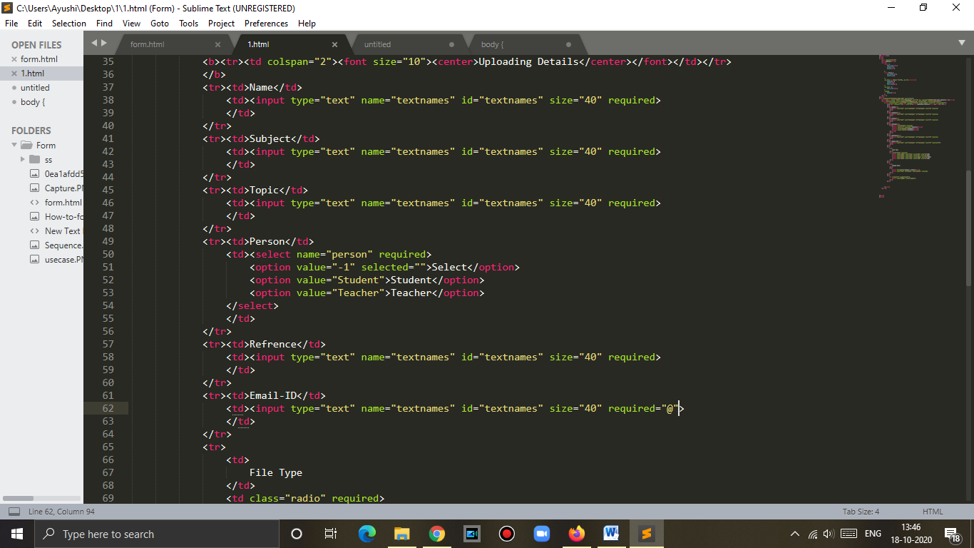

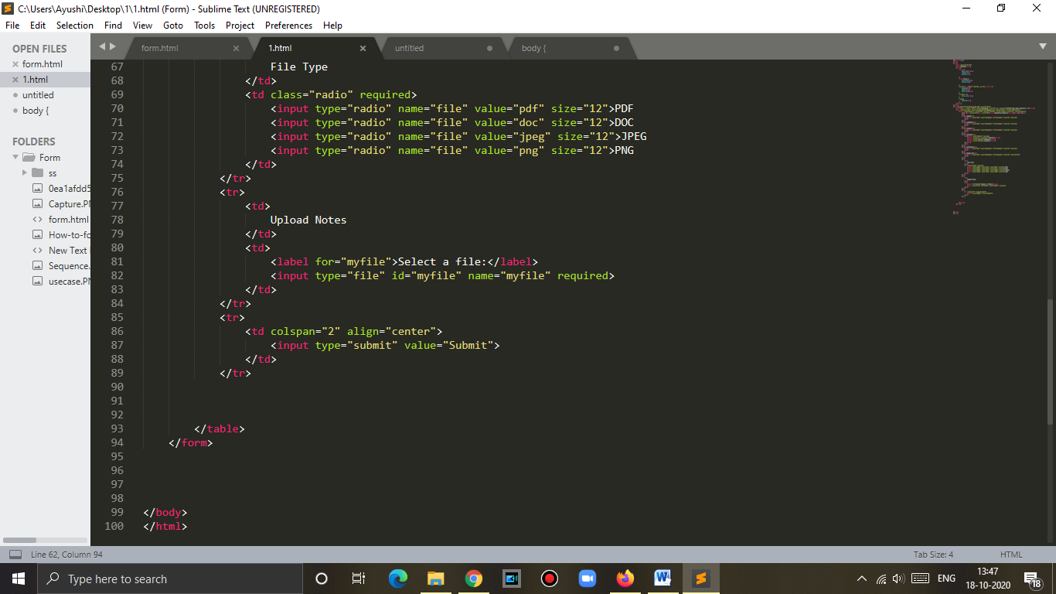

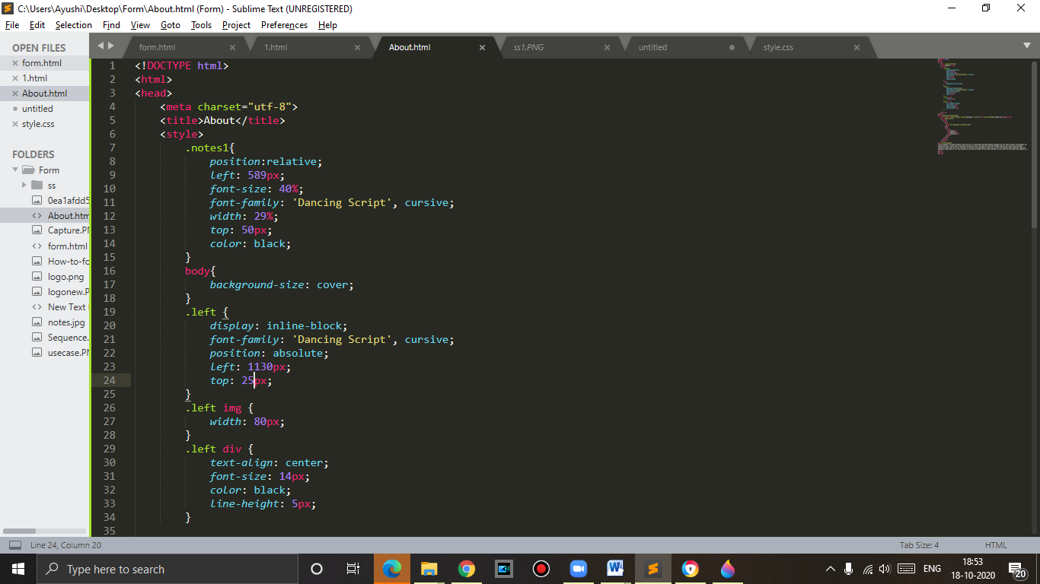

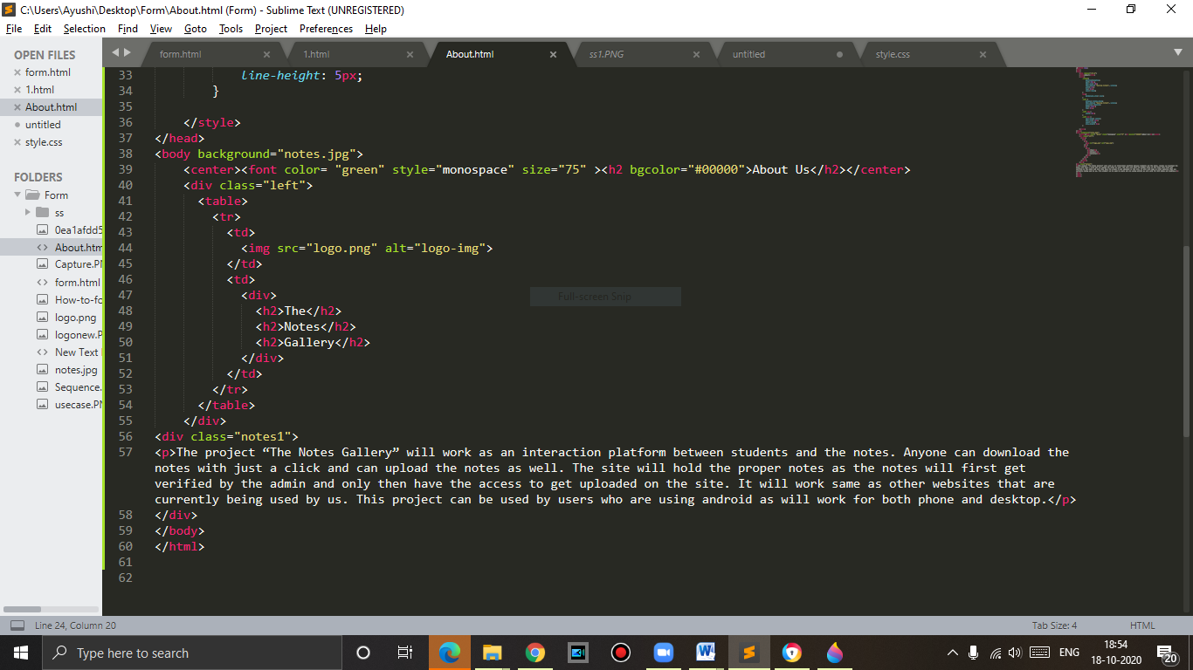

***CONCLUSION***

With the help of this project students will be able to manage important notes at the time of their need. They won’t have to roam door to door or call their colleagues for notes. All they have to do is just visit our site and download it within a click. And if they feel that their notes are good enough they can upload them as well. The students will hence be contented with their notes without any panic.

***BIBLIOGRAPHY***

**BOOKS:**

* Learning PHP, MySQL & JavaScript With JQuery, CSS & HTML5 – By Robin Nixon (3rd Edition)
* Learning Web Design - A Beginner's Guide to HTML, CSS, JavaScript, and Web Graphics - By [Jennifer Robbins](https://www.google.co.in/search?hl=en&q=Jennifer+Robbins&stick=H4sIAAAAAAAAAONgVuLSz9U3MDIrszAuecRoyi3w8sc9YSmdSWtOXmNU4-IKzsgvd80rySypFJLgYoOy-KR4uJC08SxiFfBKzcvLTEstUgjKT0rKzCsGAAMTKCpZAAAA) (5th Edition)

**SITE LINKS:**

* <https://www.beta-labs.in/p/html.html>
* <https://www.geeksforgeeks.org/>
* <https://www.w3schools.com/>
* <https://www.sololearn.com/>